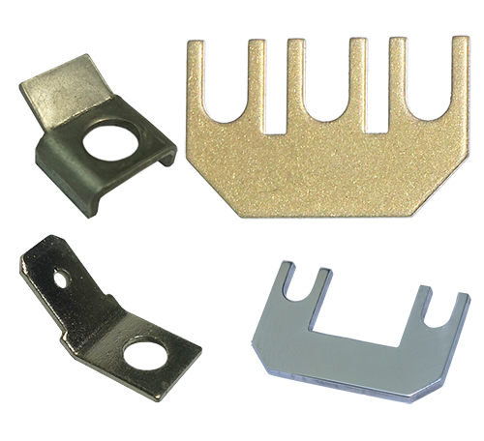

**Type 66A**

**Quick connect terminals, saddles, jumpers for connection blocks**

Tabs 4.8mm x 0.8mm with 3.1mm hole. These tabs can be mounted on the screw terminals of the BE series terminal blocks with 2.5mm² cross-section.

6.35 tabs with 4,1mm hole. They are used as replacements for the saddle on ceramic terminal blocks of the BCA and BCB series. They are not compatible with the BCC series. They retain the ability to tighten a conductor under the tab.

Saddles for M4 screw terminals.

Jumpers. They allow to easily connect 2 or 3 adjacent terminals.